13.05.2024

Create a Billing alarm at the CLoudWatch

Make sure you have created your SNS topic in the N.V

Now go to the CloudWatch

Alarms >>> Billing >>>> Create a Alarm

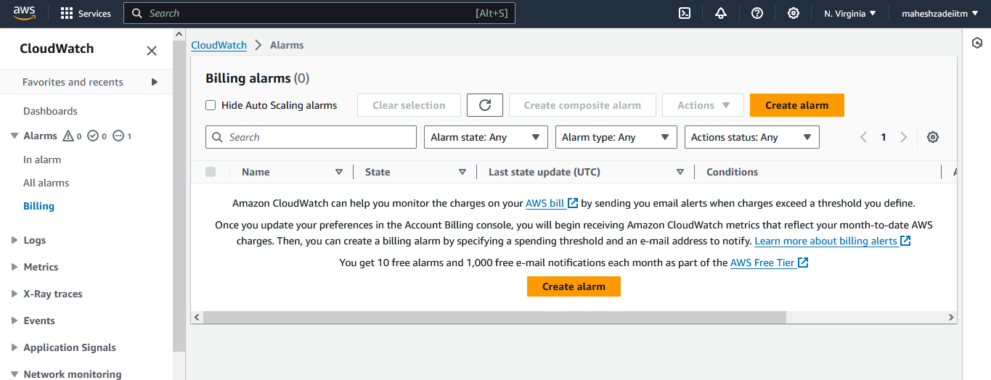

Currency and Threshold you can set as per your requirement - INR or USD

Click on next

Notification >> Select an existing SNS topic >>> Send a notification to… >>>> Choose your SNS Topic

Give the name as your desire and create

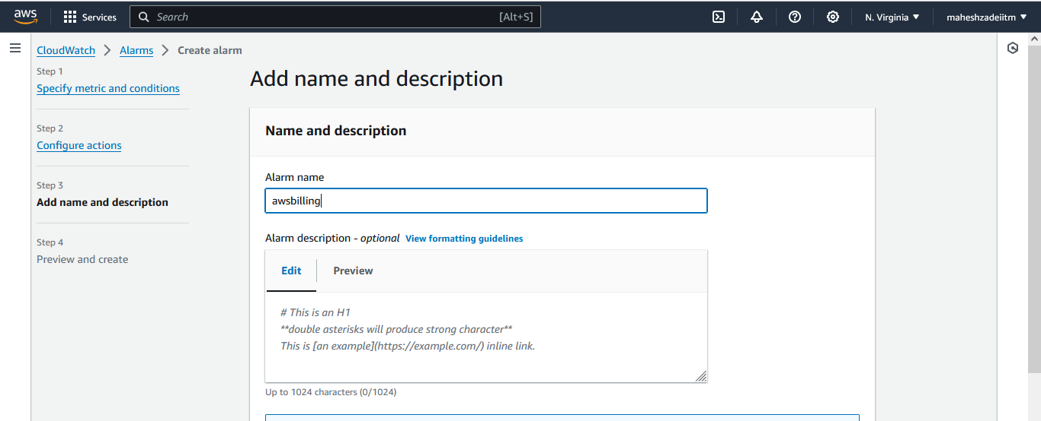

Click on create alarm

AWS CloudWatch Hands on done successfully

Pls check and confirm .

Thanks